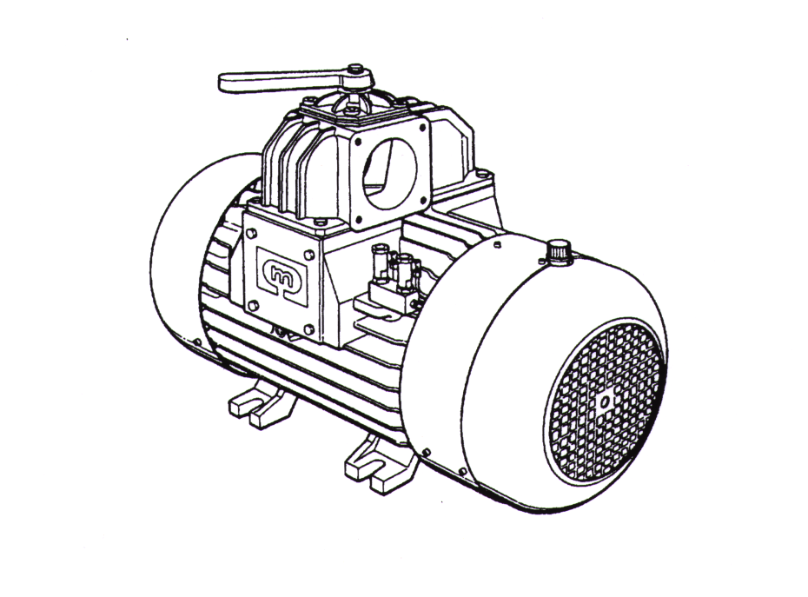

- PARTI DI RICAMBIO -
- PIECES DE RECHARGE -
- ERSATZTEILLLISTE -
- SPARE PARTS -
- DECOMPRESSORE AC5
- POMPE A VIDE AC5
- VAKUUMPUMPE AC5
- AC5 VACUUM PUMP

Pos. | Q.tà | Codice | Denominazione | Nomenclature | Bezeichnung | Denomination
1 | 1 | 4812-0209-2 | Gruppo oliatori | Graisseur | Oeler | Oil valve
2 | 1 | 4812-0216-0 | Pompa olio | Pompe à huile | Oelpump | Oil pump
3
4 | 1 | 5400-0091-0 | Calotta posteriore | Couvercle | Deckel | Cover
5 | 1 | 5534-0092-0 | Rotore completo | Rotor | Läufer | Rotor
6
7
8 | 1 | 6103-0012-0 | Coperchio | Couvercle | Deckel | Cover
9 | 1 | 6015-0006-0 | Asta livello olio | Tige | Stange | Rod
10 | 2 | 6045-0000-0 | Ventola | Hèlice | Lüfterrad | Fan
11
12 | 1 | 6103-0019-1 | Flangetta posteriore | Flasque | Flansch | Flange
13 | 2 | 6104-0141-1 | Flangia dx / sx | Flasque | Flansch | Flange
14
15 | 1 | 6104-0144-0 | Flangetta posteriore | Flasque | Flansch | Flange
16 | 6 | 6130-1009-0 | Supporto calotta | Support | Träger | Support
17
18
19 | 1 | 6400-0048-0 | Calotta anteriore | Couvercle | Deckel | Cover
20
21 | 1 | 6450-0050-0 | Fascia convogliatrice | Carter | Kasten | Case
22 | 1 | 6550-0021-0 | Mozzo per ventola | Moyen | Nabe | Hub
23 | 1 | 6560-0058-0 | Mozzo anteriore | Moyen | Nabe | Hub
24 | 3 | 6575-0073-1 | Lamella decompressori | Palette | Lamelle | Vane
25 | 1 | 6624-0056-0 | Corpo | Corps | Gehäuse | Housing
26 | 1 | 6633-0065-2 | Serbatoio olio | Reserved huile | Ölbehälter | Oil tank
27 | 1 | 6633-0069-0 | Coperchio serbatoio olio | Couvercle | Deckel | Cover
28 | 2 | 6634-0009-0 | Piastra chiusura | Plaque | Platte | Plate
29
30 | 1 | 6730-0201-0 | Raccordo asta olio | Raccordi tige | Anschulβ Stange | Fitting rod
31 | 1 | 6760-1277-0 | Tubo lubrif. ant. sx. | Tuyau | Schlauch | Tube
31 | 1 | 6760-1273-0 | Tubo lubrif. ant. dx. | Tuyau | Schlauch | Tube
32 | 1 | 6760-1223-0 | Tubo 1° mandata | Tuyau | Schlauch | Tube
33 | 1 | 6760-1224-0 | Tubo cuscinetto anteriore | Tuyau | Schlauch | Tube
34 | 1 | 6760-1225-0 | Tubo 2° mandata | Tuyau | Schlauch | Tube
35 | 1 | 6760-1271-0 | Tubo lubrif. post. sx. | Tuyau | Schlauch | Tube
35 | 1 | 6760-1272-0 | Tubo lubrif. post. dx. | Tuyau | Schlauch | Tube
36 | 2 | 6760-1297-0 | Tubo 1° e 2° mandata | Tuyau | Schlauch | Tube
37 | 5 | 6805-0325-0 | Guarnizione | Joint | Dichtung | Gasket
38 | 1 | 6760-1226-0 | Tubo cuscinetto posteriore | Tuyau | Schlauch | Tube
39 | 2 | 6806-0052-0 | Guarnizioni flange | Joint | Dichtung | Gasket
40 | 1 | 6806-0053-0 | Guarnizioni cop. serb. | Joint | Dichtung | Gasket
41 | 1 | 6760-1298-0 | Tubo | Tuyau | Schlauch | Tube
42 | 1 | 6810-0138-0 | Fermo valvola | Arrèt | Haltplatte | Stop Plate
43 | 1 | 6830-0137-0 | Rondella mozzo ant. | Rondelle | Federscheibe | Gasket
44 | 1 | 6760-1298-0 | Tubo | Tuyau | Schlauch | Tube
45 | 1 | 6806-0035-0 | Guarnizione | Joint | Dichtung | Gasket
46 | 1 | 4443-0019-0 | Valvola di ritegno | Soupape | Ventil | Valve
47
48
49 | 1 | 92-1002-004 | Anello di tenuta | Anneau d’etanchèitè | Simmerring | Oil seal
50 | 1 | 92-1003-058 | Anello O.R. | Anneau torique | Rundschnurring | O-ring
51 | 1 | 92-1003-103 | Anello O.R. | Anneau torique | Rundschnurring | O-ring
52 | 1 | 92-1003-153 | Anello O.R. | Anneau torique | Rundschnurring | O-ring
53 | 2 | 92-1027-054 | Anello di tenuta | Anneau d’etanchèitè | Simmerring | Oil seal
54 | 2 | 92-1027-057 | Anello di tenuta | Anneau d’etanchèitè | Simmerring | Oil seal
55 | 1 | 92-4032-101 | Raccordo orientabile | Raccord | Anschulβ | Fitting
56 | 11 | 92-4063-050 | Raccordo dritto | Raccord | Anschulβ | Fitting
57 | 2 | 92-4061-050 | Raccordo 90° | Raccord | Anschulβ | Fitting
58
59
60 | 1 | 93-0005-022 | Anello interno | Anneau | Ring | Ring
61 | 1 | 93-0005-021 | Anello interno | Anneau | Ring | Ring
62 | 1 | 92-5070-000 | Tappo conico | Bouchon | Deckel | Plug
63 | 1 | 93-1005-005 | Cuscinetto radiale | Roulement | Kugellager | Ball bearing
64 | 1 | 93-1012-004 | Cuscinetto | Roulement | Kugellager | Ball bearing
65
66
67 | 5 | 96-1075-002 | Vite | Vis | Schraube | Screw
68 | 2 | 96-1073-003 | Vite | Vis | Schraube | Screw
69 | 12 | 96-1075-001 | Vite | Vis | Schraube | Screw
70 | 3 | 96-1075-004 | Vite | Vis | Schraube | Screw
71 | 4 | 96-1075-003 | Vite | Vis | Schraube | Screw
72 | 12 | 96-1077-005 | Vite | Vis | Schraube | Screw
73 | 1 | 96-1077-008 | Vite | Vis | Schraube | Screw
74 | 14 | 96-1078-111 | Vite | Vis | Schraube | Screw
75
76 | 2 | 96-1090-000 | Grano | Goujon | Stiftschraube | Set screw
77 | 2 | 96-1104-011 | Vite | Vis | Schraube | Screw
78 | 1 | 96-1125-002 | Vite | Vis | Schraube | Screw
79 | 2 | 96-2025-003 | Dado | Ecru | Mutter | Nut
80 | 4 | 96-4001-004 | Rosetta | Rondelle | Federsheibe | Washer
81 | 1 | 96-3001-032 | Anello “Seeger” | Anneau “Seeger” | Ring “Seeger” | Ring “Seeger”
82 | 1 | 96-3002-067 | Linguetta | Clavette | Keil | Key
83 | 10 | 96-4007-001 | Rosetta piana | Rondelle | Federscheibe | Washer
84 | 2 | 96-4015-005 | Rosetta piana | Rondelle | Federscheibe | Washer
85 | 1 | 96-4018-019 | Spina elastica | Axe èlastique | Stift | Elastic pin
86 | 4 | 96-4027-004 | Spina cilindrica | Axe | Stift | Pin
87 | 1 | 96-5023-000 | Tappo carico olio | Bouchon | Deckel | Plug
88 | 2 | 96-5041-003 | Golfaro acciaio | Cheville à oeillet | Ösenschraube | Eve nut
89 | 1 | 96-3003-037 | Anello “Seeger” | Anneau “Seeger” | Ring “Seeger” | Ring “Seeger”
90 | 1 | 8611-0036-0 | Collettore completo | Collecteur | Rumpenoberteil | Manifold
91 | 1 | 6024-0004-0 | Leva | Levier | Hebel | Handle
92 | 1 | 6264-0028-0 | Deviatore | Dèviateur | Umschaltvorrichtung | Change-over Device
93 | 1 | 6264-0068-0 | Collettore | Collecteur | Rumpenoberteil | Manifold
94 | 1 | 6633-0033-0 | Coperchio deviatore | Couvercle | Flansch | Flange
95 | 1 | 6806-0016-0 | Guarnizione | Joint | Deckel | Cover
96 | 1 | 6900-0034-2 | Molla | Ressort | Feder | Spring
97 | 1 | 92-1000-074 | Anello di tenuta | Anneau d’etanchèitè | Dichtung | Gasket
98 | 5 | 96-1075-003 | Vite | Vis | Schraube | Screw
99 | 1 | 96-4001-002 | Rosetta elastica | Rondelle èlastique | Fedrscheibe | Spring Washer
100 | 1 | 96-4005-005 | Rosetta piana | Rondelle | Fedrscheibe | Washer
 |  | 8899-0109-0 | Serie guarnizioni AC5 | Jeu de joints AC5 | Dichtungsatz | Kit of gaskets AC5

