RBVM BLOWER RANGE

POSITIVE DISPLACEMENT AIR BLOWERS

BULK BLOWING VEHICLES TYPE RBVM 68, 610 & 613

Features:- (3 sizes available)
- Simple strong, robust and reliable unit giving years of trouble free service.
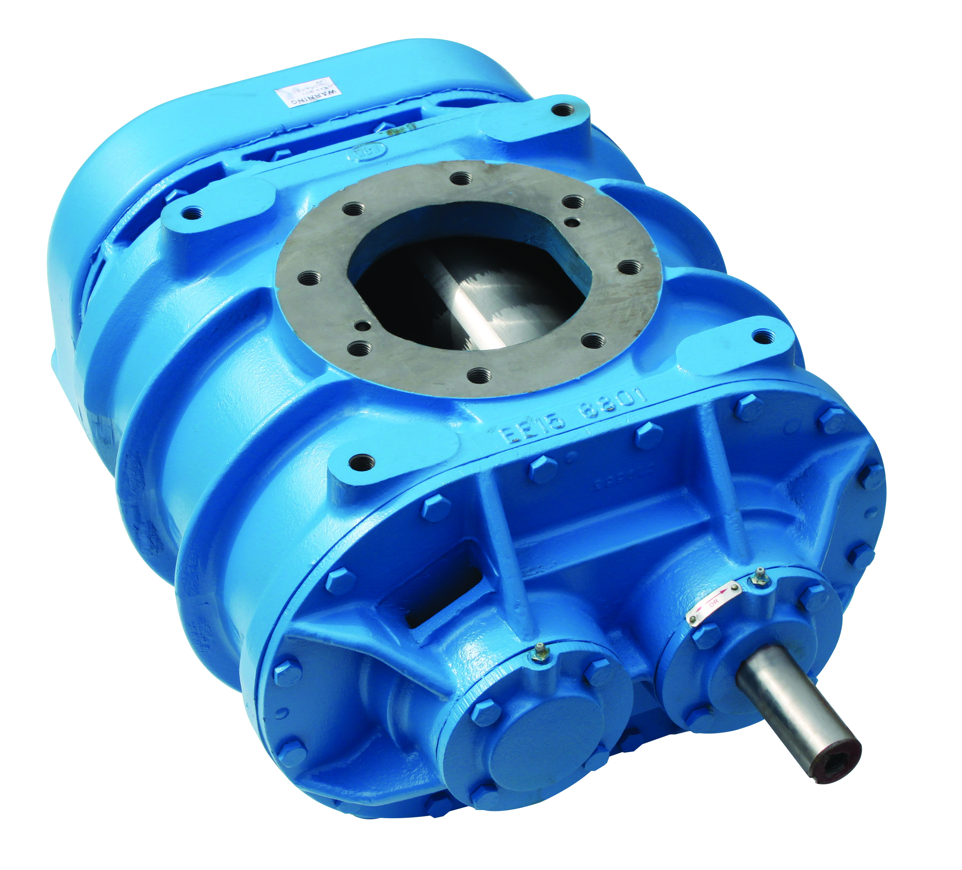
- The blower can be operated with a longitudinal inclination of up to 10° without risk of oil starvation: this is of particular importance when the vehicle is not standing on level ground.
- Air gaps at each end of the cylinder ensure that there can be no contamination by oil or oil vapours.
- Centre timing permits operation in either direction – vertical or horizontal air flow.
- Suitable for combined pressure and exhauster applications with vacuum up to 475 mbar.
- Oil bath both end available RBVMO type.

Specification
Casing: The cylinder and head plates are manufactured from cast iron.
Impellers and Shafts: The impellers and shafts are of one-piece construction, with axial location and centre timing.
Gears: The straight spur timing gears are taper mounted onto the shafts and operate in a totally enclosed gear case.
Bearings: The bearings are of generous proportions to give long operational life. Grease lubricated angular contact locating bearings are used at the drive end. Roller bearings at the gear end are splash lubricated from the gears.
Lubrication: A special design gear trough controls the lubricating oil system, allowing the blower to operate at maximum speeds without the need for an oil pump. Oil throwers are fitted behind each gear end bearing: these do not require maintenance.
Air Gaps: The blower is constructed with an air gap at each end, between bearing and cylinder, to ensure that the delivered air cannot become contaminated by oil or oil vapours.
Timing: When a standard machine is to provide a horizontal airflow, the top shaft is extended for the drive. If the machine is mounted for vertical airflow, the drive shaft is on the right. The position of the shaft is given when looking at the machine from the drive shaft end. Centre timing enables the blower to operate in either direction. If the machine is required with a bottom or left hand shaft extended, all that needs to be done is to turn the gear case and trough 180˚. Detailed instructions are given in the installation and operating instruction folder.

MODEL | SPEED  rpm | FLOW  m³/hr | PRESSURE  Barg | WEIGHT  kg
RBVM68 | 1000 - 1450  1450 – 2400 | 350 – 600  600 - 1200 | 1  1.2 | 120
RBVM610 | 1000 – 2400 | 400 - 1500 | 1 | 143
RBVM613 | 1000 - 2400 | 600 - 2000 | 0.85 | 165


Tel: 01782 710282 Fax: 01782 710126
Email: office@transairvac.com Website: www.transairvac.com

