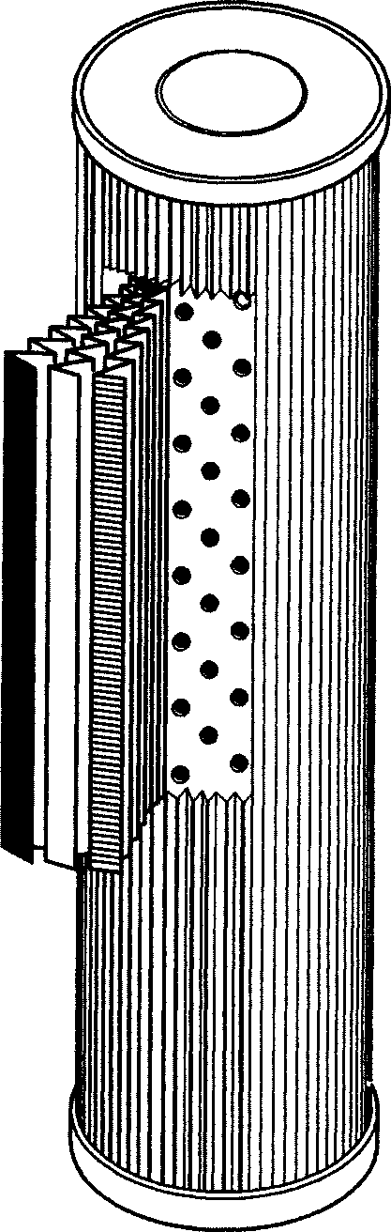
SPECIFICATION FOR FIL.004.13
Drawing ref :- TAV.1440

FLOW RATE :- 300 – 900 m3/hr (176 – 530 cfm)

PRESSURE :- 5 bar (absolute)

TEMPERATURE :- -40˚C to 150˚C Continuous

ELEMENT :- Pleated construction .
Outer mesh :- 40`s square mesh 316 stainless steel
Inner mesh :- 80`s square mesh 316 stainless steel
Filter media :- 5 micron absolute( 98% 1 µ )
316 stainless steel (sintered fibre.)

ASSEMBLY :- Welded seam. Epoxy bonded end caps.

TESTING :- Integrity test by bubble point .

ISO :- All elements carry works order production number .
Unique to each element

